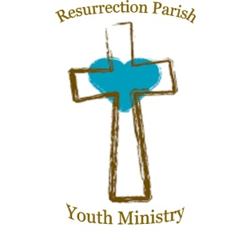
RESURRECTION PARISH
Registration for Confirmation 2026

Name of Youth_________________________________________________ Grade______________

Home Address_______________________________________________________________________________
Parent/guardian name and email_________________________________________________________________

Parent/guardian phone number__________________________

Parent/guardian name and email _________________________________________________________________

Parent/guardian phone number__________________________

Youth email_________________________________________________________________________________

Youth phone number______________________________ Youth’s date of birth________________________
City and State of Birth______________________________ Youth’s Date of Baptism__________________

Youth’s Church of Baptism and address________________________________________________________

________________________________________________________________________________________

We require a copy of the Baptismal Certificate if the Youth was not Baptized at Resurrection. Please include a copy of the certificate attached to the form if it has not been previously provided. Thank you!

Father’s Name__________________________________ Religion______________________________

Mother’s Name_________________________________ Religion______________________________

Mother’s Maiden Name__________________________

Each youth preparing for any sacrament including Confirmation must be enrolled in our religious education program (youth group) or attending Catholic School.

Is your youth enrolled in our religious education program (youth group)____________________

Is your youth enrolled in a Catholic School?________________________ If so which one?____________________

Thank you!

Elaine Little,

Coordinator of Faith Formation,
Resurrection Parish

